**How to Play Sounds on a Web-Site?**

How could I play game audio via JavaScript?

var audio = new Audio('audio_file.mp3'); //'audio_file.mp3 is file name

audio.play();

<https://stackoverflow.com/questions/9419263/how-to-play-audio>

Download audio sounds from different websites like

<https://pixabay.com/sound-effects/search/kick%20bass/?order=None>

search **new Audio() javascript**

<http://developer.mozilla.org/en-US/docs/Web/API/HTMLAudioElement>

**Syntax: //HTML Play Sounds**

mySound = new Audio([URLString]);

<name> = new Audio<File_Name>; file name is along with location like ('sounds/tom1.mp3')

We can add play time as well as other methods let’s see in above website.

**Play Methods:**

Syntax:

var promise = HTMLMediaElement.play();

<http://developer.mozilla.org/en-US/docs/Web/API/HTMLMediaElement/play>

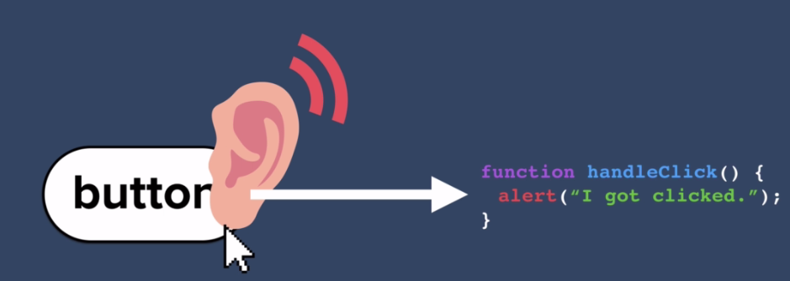

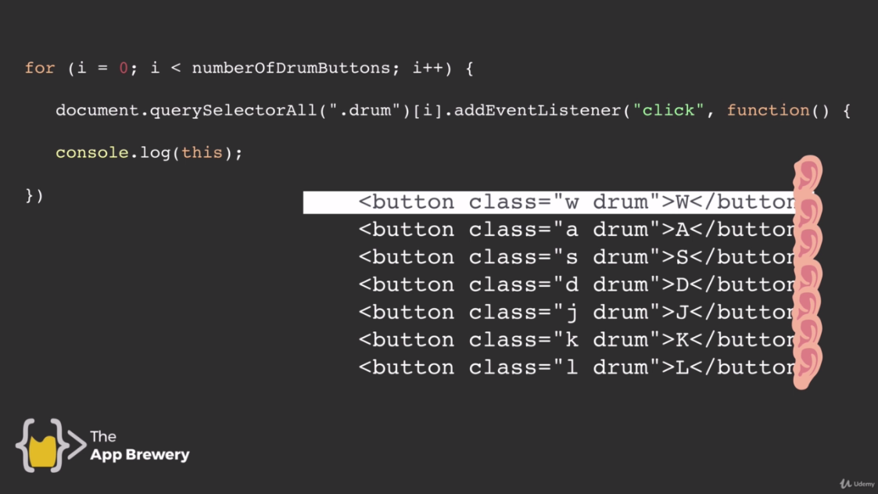

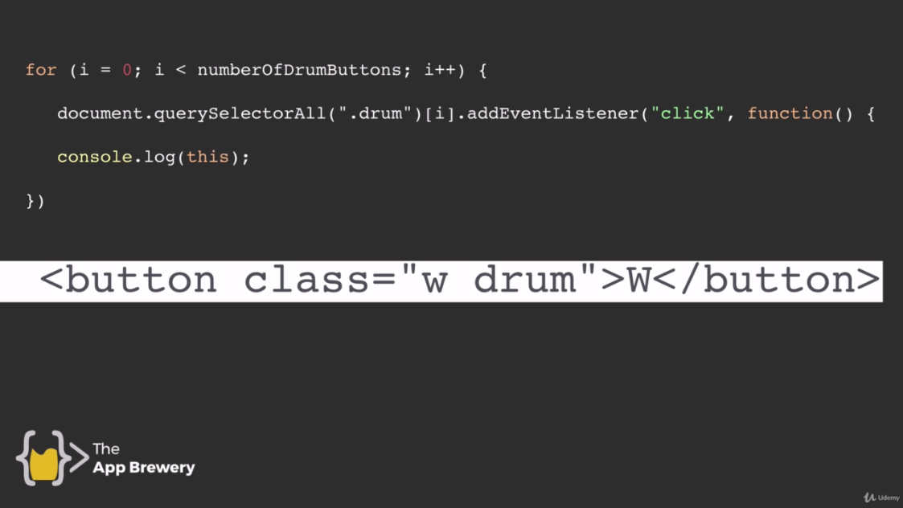

***Code:***

**Index1.html:**

<!DOCTYPE html>

<html lang="en" dir="ltr">

<head>

<meta charset="utf-8">

<title>Drum Kit Sounds</title>

<link rel="stylesheet" href="styles1.css">

<link href="https://fonts.googleapis.com/css2?family=Arvo" rel="stylesheet">

</head>

<body>

<h1>Drum 🥁 Kit</h1>

<div class="Set">

<button class="w drum">w</button>

<button class="a drum">a</button>

<button class="s drum">s</button>

<button class="d drum">d</button>

<button class="j drum">j</button>

<button class="k drum">k</button>

<button class="l drum">l</button>

</div>

<script src="index1.js" charset="utf-8"></script>

</body>

<footer class="footer">

Made with ❤️ in London.

</footer>

</html>

**Index1.js:**

//Method 2

var noOfDrumButtons = document.querySelectorAll(".drum").length;

for (var i = 0; i < noOfDrumButtons; i++) {

//W button

document.querySelectorAll(".drum")[0].addEventListener("click",function(){

var audio = new Audio('sounds/tom1.mp3');

audio.play();

//console.log(this.innerHTML); //To print character in inspect

//console.log(this.style.color = 'white');

this.style.color = 'white' //This and above line will change text color to white

});

//a button

document.querySelectorAll(".drum")[1].addEventListener("click",function(){

var audio = new Audio('sounds/dr-tom.mp3');

audio.play();

this.style.color = 'white' //This and above line will change text color to white

});

//S button

document.querySelectorAll(".drum")[2].addEventListener("click",function(){

var audio = new Audio('sounds/kick.mp3');

audio.play();

this.style.color = 'white' //This and above line will change text color to white

});

//d button

document.querySelectorAll(".drum")[3].addEventListener("click",function(){

var audio = new Audio('sounds/smooth-beat.mp3');

audio.play();

this.style.color = 'white' //This and above line will change text color to white

});

//j button

document.querySelectorAll(".drum")[4].addEventListener("click",function(){

var audio = new Audio('sounds/tom2.mp3');

audio.play();

this.style.color = 'white' //This and above line will change text color to white

});

//k button

document.querySelectorAll(".drum")[5].addEventListener("click",function(){

var audio = new Audio('sounds/tom3.mp3');

audio.play();

this.style.color = 'white' //This and above line will change text color to white

});

//l button

document.querySelectorAll(".drum")[6].addEventListener("click",function(){

var audio = new Audio('sounds/dr-tom.mp3');

audio.play();

this.style.color = 'white' //This and above line will change text color to white

});

}

/*

//For Single button

document.querySelector(".drum").addEventListener("click", handleClickW); //On first button on web-page

function handleClickW(){

var audio = new Audio('sounds/tom1.mp3');

audio.play();

this.style.color = 'white'; //Change color to white

}

*/

**Styles1.css:**

body{

background-color: #483D8B;

text-align: center;

color: #fff;

font-family: "swap", Arvo;

}

h1{

text-align: center;

/* color: #fff; */

font-size: 5rem;

padding-bottom: 5%;

}

.footer{

padding-top: 7%;

}

.drum{

padding: 2% 3%;

margin: 1%;

border-radius: 15%;

border: solid 10px;

border-color: #6A5ACD;

font-size: 2rem;

font-weight: bold;

color: #C71585;

}

/* Add background images to each button*/

.w{

background-image: url('images/title.jpg');

}

.a{

background-image: url("images/kick-drum.png");

background-size: contain;

}

.s{

background-image: url('images/crash-drum.png');

background-size: contain;

}

.d{

background-image: url("images/music1.jpg");

background-size: contain;

}

.j{

background-image: url("images/music2.jpg");

background-size: cover;

}

.k{

background-image: url("images/music3.jpg");

background-size: contain;

}

.l{

background-image: url("images/music4.jpg");

background-size: contain;

}